**List Permissions**

List permissions are a bit special compared to document libraries in SharePoint. They have the same permission structure, so you can give users or groups unique permissions to the list. But besides the list permissions, we can also set permission on item-level in SharePoint.

So first the list permissions. With the list selected:

1. Click on **Settings**
2. Open **List settings**

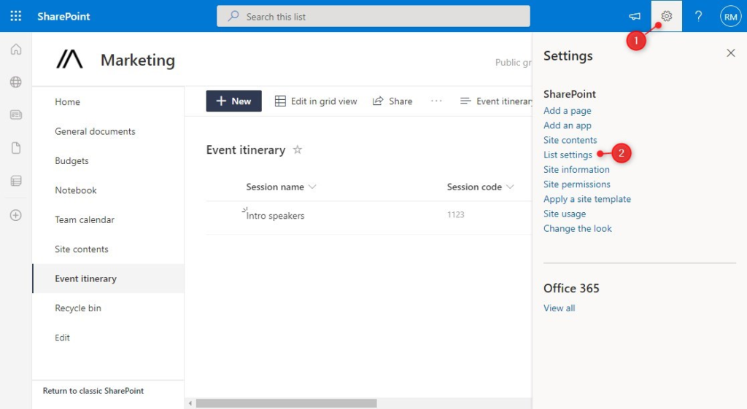SharePoint List Settings

In the settings screen, we can open the permission for this list (3). Also note the Advanced Settings option, which we will use later for the item-level permissions.

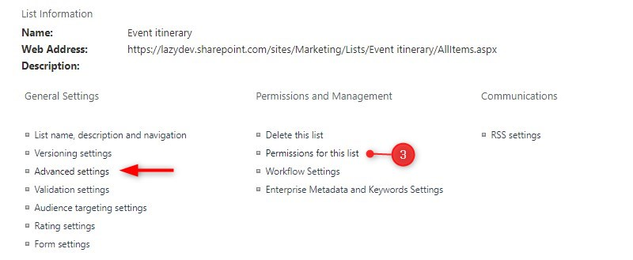

We first need to **stop inheriting** the site-level permissions before we can add unique permissions to the list. After stopping the inheritance, you can add or remove user or security groups from the list. Refer to the steps above for more details about this.

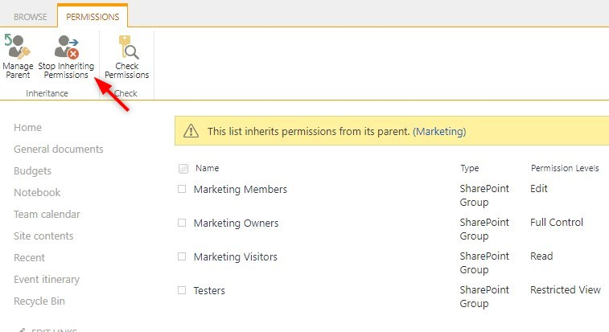

**Item-Level Permissions**

A special feature of lists in SharePoint is that we can set permissions on item level. The permissions are limited to the question if a user can view and/or edit only their own items or all items. So we can give a user read-all access, which allows them to view all items on the list. But limit the create and edit permission to only the items created by the user.

To set the item permissions, click on **Advanced Settings** in the **List settings**. Here we can set the item-level permissions:

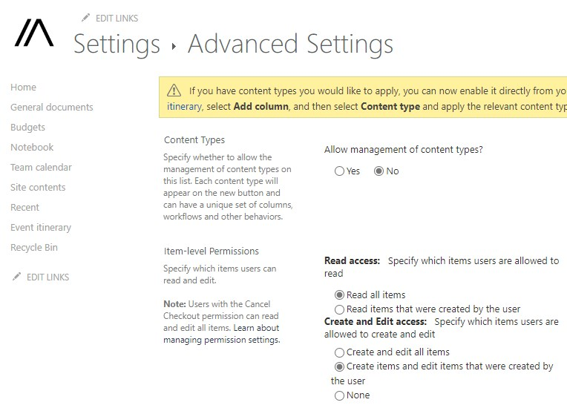Item-level permissions

We can’t add custom permissions levels to the items, but these options should be more than sufficient in most cases.